2023 Coastal Master Plan HSI FWOA QA/QC Notes

* 1. Eastern Oyster

The oyster HSI FWOA results are reasonable. There are some abrupt changes in suitability where one compartment has relatively high suitability scores but its neighboring compartment has a score of 0.0 (this is particularly noticeable in Terrebonne/Timbalier Bay). This pattern is because the simulated salinities in the unsuitable compartment are slightly above the upper threshold(s) for the minimum monthly salinity and/or the annual mean salinity variables, and thus the compartment receives a zero score. This doesn’t make sense considering oysters still can occur in these higher salinity areas, but their survivability would be poor due to disease and predators. Therefore, I suggest modifying the relationships so that suitability scores are 0.001, rather than 0.0, above 20 ppt for the minimum monthly salinity variables and above 25 ppt for the annual mean salinity variable*.*

There is an apparent inconsistency in the model code for calculating the decadal cultch data to be used by the fish, shrimp, and blue crab HSIs. The code is correctly averaging the oyster HSI scores for each decade, but it appears that the resulting average for each compartment is multiplied by 100 and expressed as percent cultch in the resulting csv files (perhaps this occurs in Line 424 of ICM_HSI_standalone.py?). The later HSI code, however, is actually using the average oyster HSI score expressed as a decimal (with the threshold for using the alternate structural habitat SI being an average score of 0.5; for example see Line 292 of HSI.py). Therefore, either the Standalone.py code or the HSI.py code needs to be changed for consistency. Considering the 0.5 threshold is also used in the HSI technical report, it may make more sense to modify the Standalone.py code.

* 1. Fish, Shrimp, and Blue Crab

There are generally no issues with the brown shrimp, white shrimp, blue crab, gulf menhaden, spotted seatrout, and largemouth bass HSI FWOA results. The large juvenile white shrimp results, however, are unreasonable as expected, and therefore I suggest deactivating that part of the HSI model code until future model improvement efforts can find a solution for this model.

There is an apparent problem with the simulated water temperature data during the last decade of the S07 run (year 44 on). Nearly all of the values in the “t” (temperature) column of the csv files are ‘nan’, and the values in the “t1” column are accordingly low. The data in the “t1” column are temperatures truncated to the range found in the original datasets, so apparently when the value is ‘nan’ the value in truncated to the low end of the range for that species. This results in unreasonably low suitability scores during the last decade for most species. The relative lack of temperature data in the latter years of S07 needs to be investigated.

Relatively low suitability scores are noted for small juvenile white shrimp, adult gulf menhaden, and adult spotted seatrout (scores largely <0.8 for white shrimp and seatrout, and <0.9 for menhaden). This was observed in the 2017 Master Plan for adult menhaden and adult seatrout, and is due to the average simulated water temperatures not reaching the optimal levels indicated by the HSI models. However, this now also appears to be the case for small juvenile white shrimp, where 2023 suitability scores are lower than seen for the 2017 Master Plan because average temperatures from June through December are slightly warmer and thus do not reach optimal suitability levels. This is probably something we’ll have to accept until future model improvement efforts can investigate methods to better account for intra-annual temperature variability in the HSI calculations (such as the attempt to include Julian Date in the models). However, it may be worth investigating why water temperatures are seemingly slightly higher in the 2023 ICM simulations as compared to 2017 (is this due to the future environmental scenarios used for 2023?).

* 1. Crayfish

Aside from much of the Atchafalaya Basin and a few other areas, the crayfish FWOA suitability scores are 0.0 across the ICM domain. The limiting factor causing this pattern is the low number of cells that have suitable August to November water depths (e.g. during Year 03 of the S07 FWOA simulation only 10% of the model cells had water depths in the suitable range). The time periods used for the two hydrology variables were adjusted for the 2023 Master Plan to better reflect the simulated high- and low-water periods, and the test results (using 2017 FWOA data) had more cells with suitable August to November water depths and thus more suitable habitat across the domain (see figures below). This suggests that the issue may be related to the 2023 FWOA stage and/or grid cell elevation data. Alternatively, it is possible that the August to November time period may still overlap some with the simulated high-water period, and thus may not be appropriate. Therefore, I suggest testing a couple of different hydrological time periods in order to better match the ICM simulations, i.e., September to December/January to August and October to December/January to September.

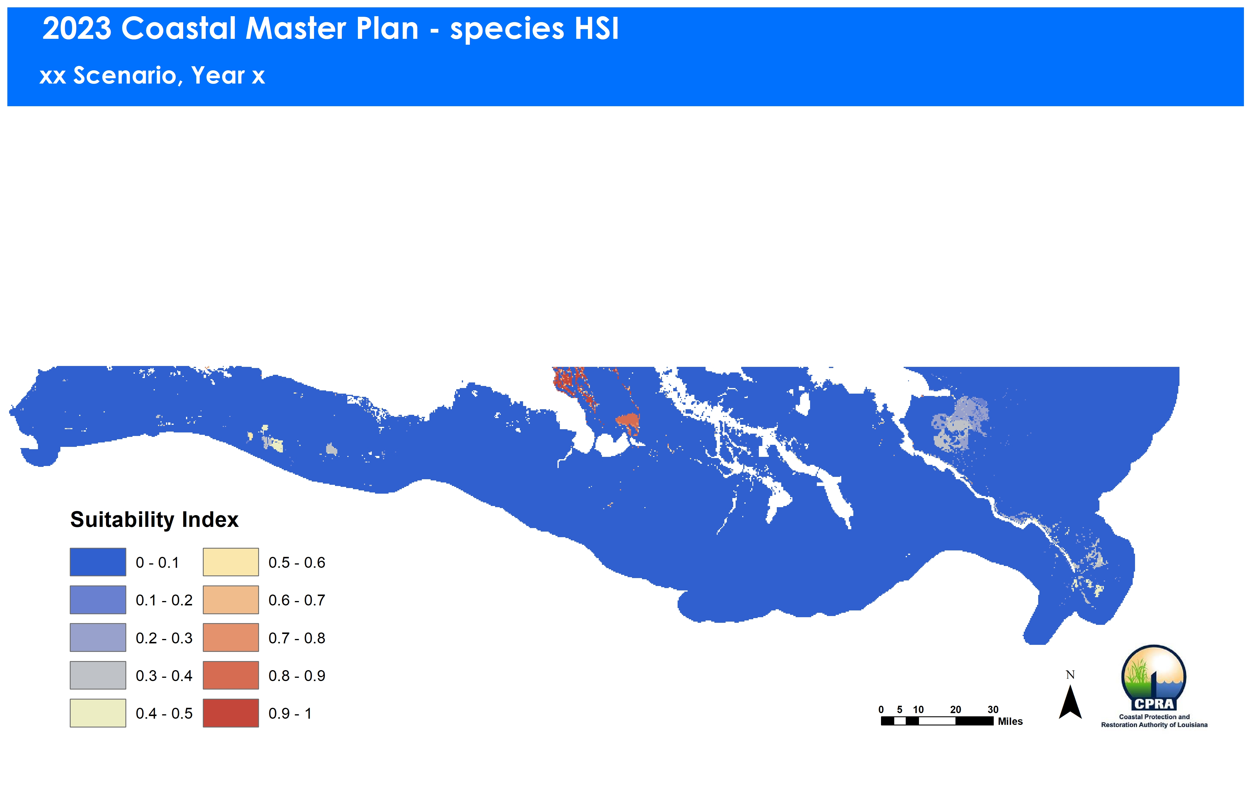 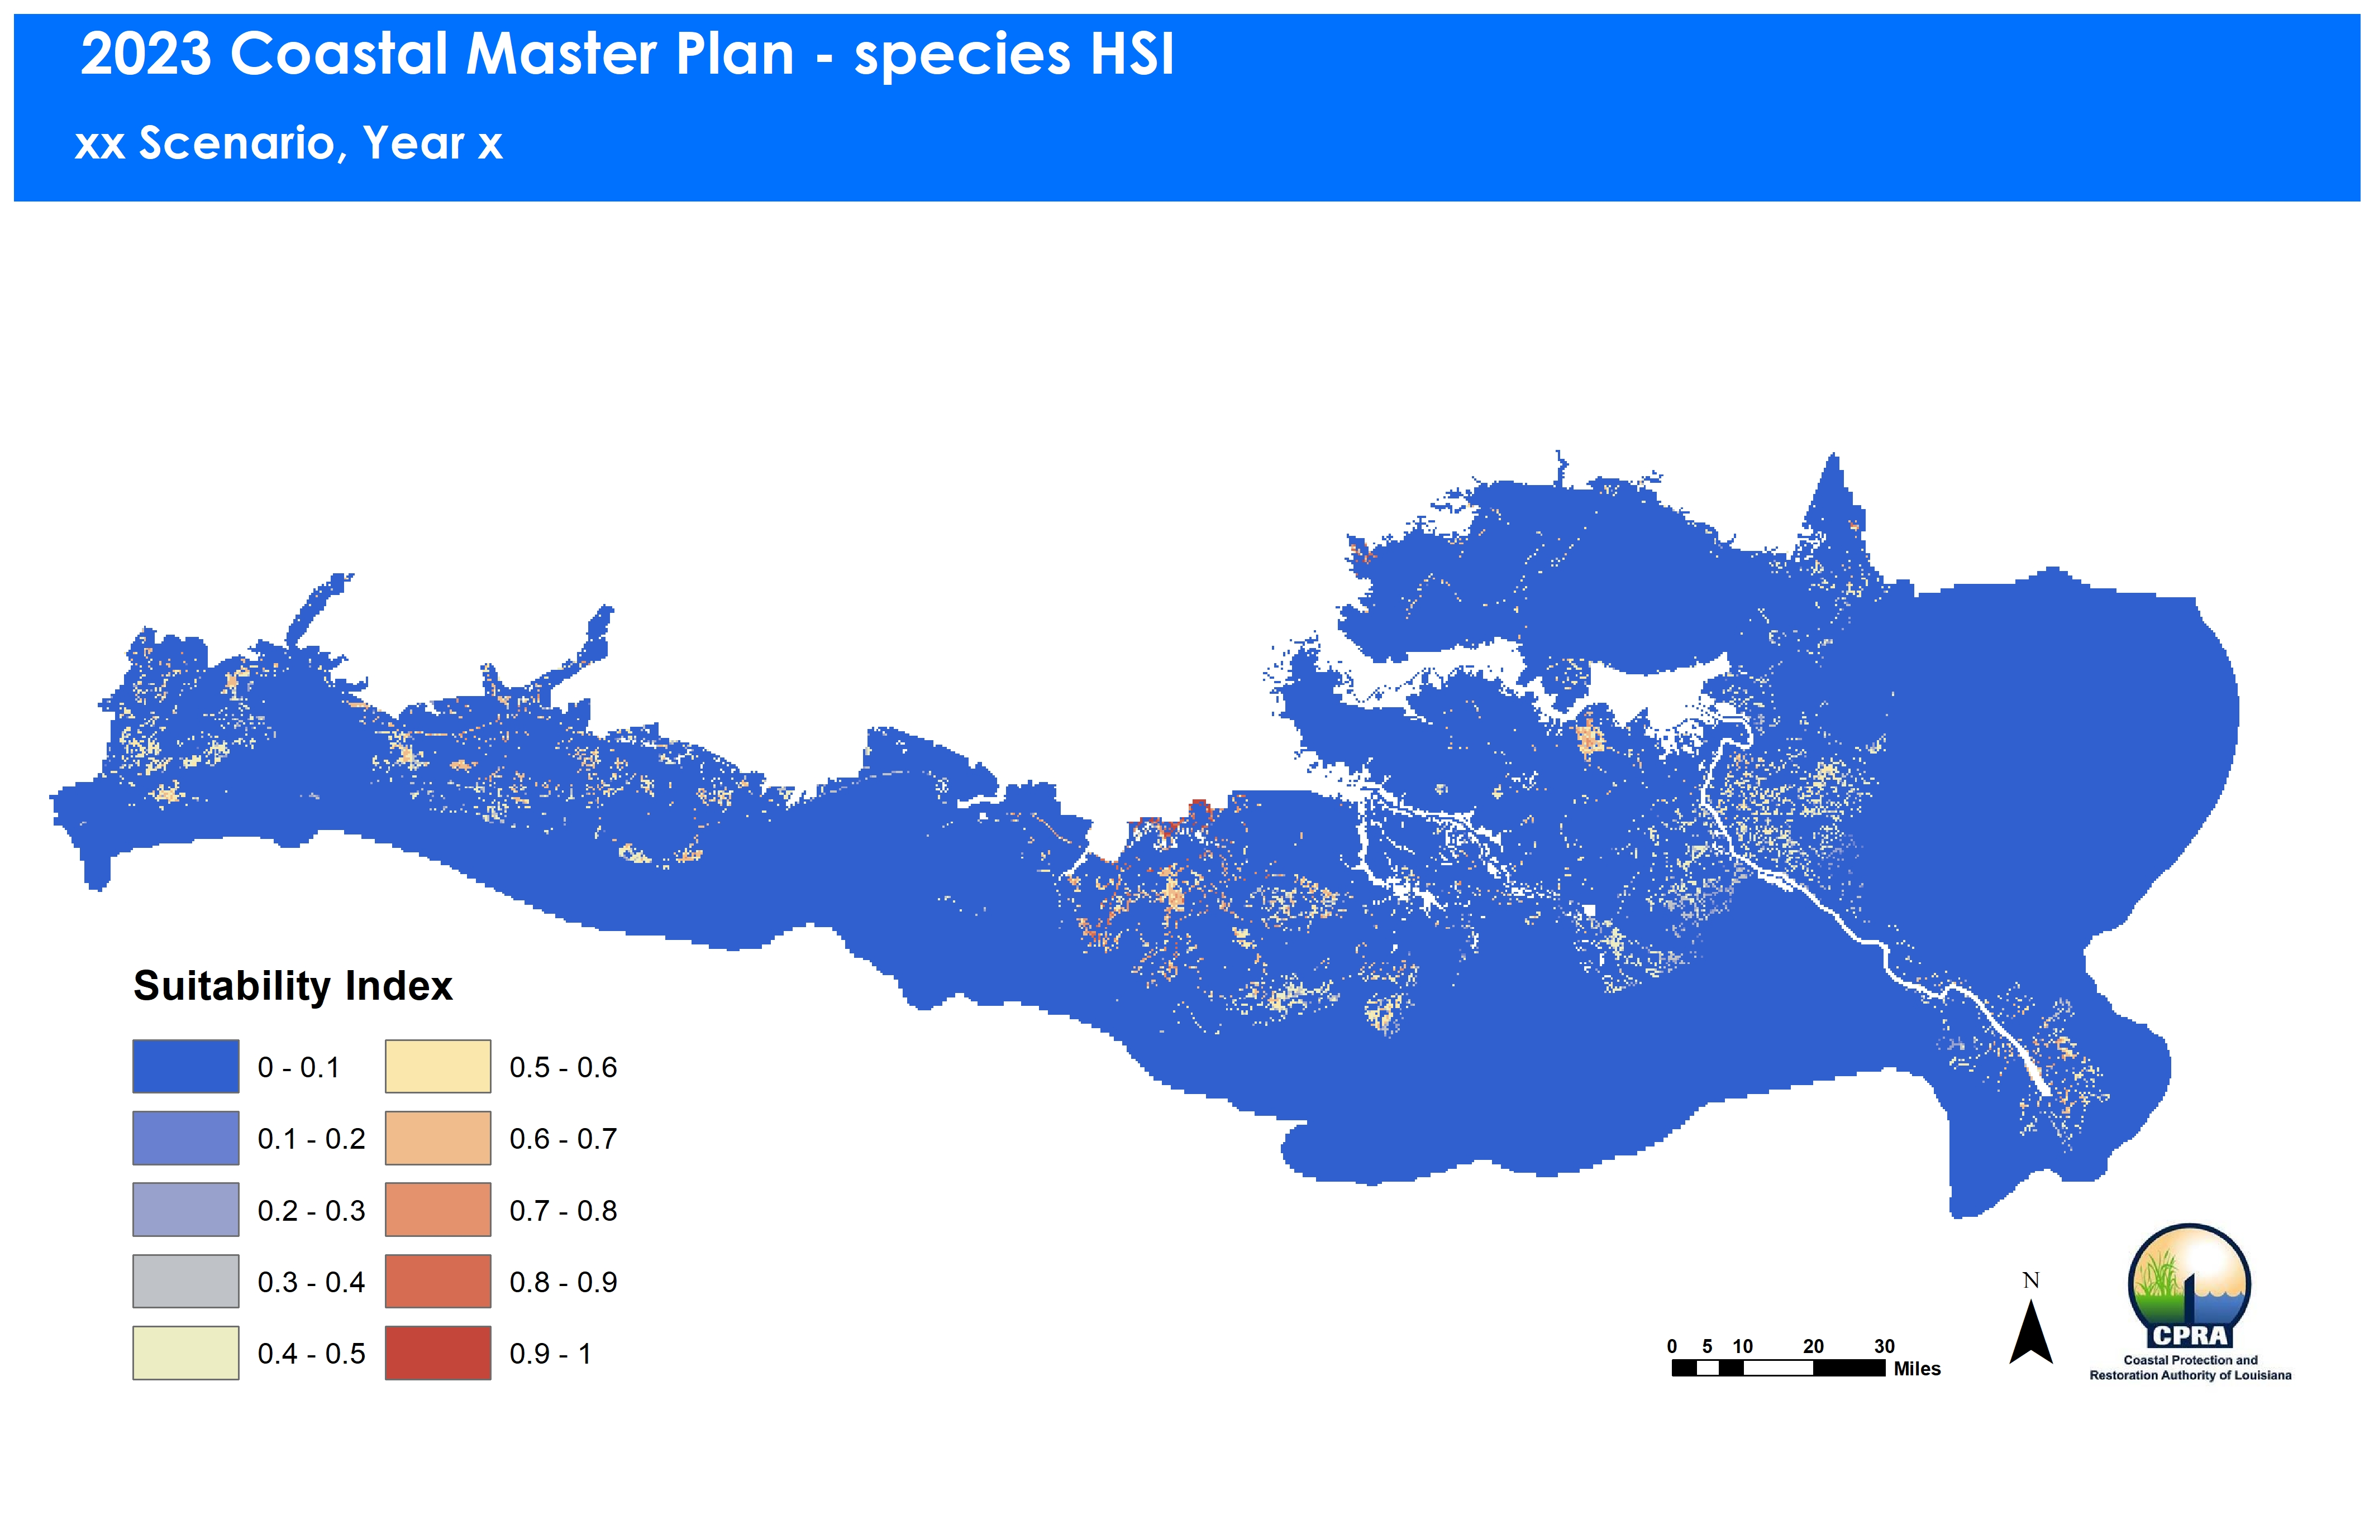

2023 Crayfish HSI FWOA results 2023 Crayfish HSI test results

* 1. Alligator

The alligator HSI FWOA results are generally reasonable. There are some areas, such as Terrebonne, where suitability scores are lower than expected. This is apparently due to relatively high, and less suitable, water levels above the marsh surface in these areas. Water levels, in general, appear to be much higher in the 2023 FWOA than in the 2017 simulations. For example, in Year 03 of the 2023 FWOA simulation, only 2% of the grid cells had water depths near optimal for alligator; whereas in Year 10 of the 2017 Master Plan simulation (which similarly includes diversion effects), 14.5% of the cells had water depths near optimal. These high water levels don’t affect the alligator results as much as others (see seaside sparrow), but it is worth investigating whether there are issues with the 2023 FWOA stage data, marsh elevation data, or alligator HSI water depth variable calculations.

In addition, there appears to be an error in the production of csv files for the alligator HSI model. The salinity data used in the HSI calculations appear under the “deep” column of the csv files and the percent edge data appear under the “s” (salinity) column. The “deep” column shouldn’t have any real data in it because that model variable isn’t used (the 2017 csv files had ‘9999’ in that column for all cells). A minor adjustment to the HSI code (Line 1476 of HSI.py?) needs to be made to correct the transposition error in the csv files.

* 1. Seaside Sparrow

Aside from barrier shorelines, barrier islands, and a few other high-elevation areas, the seaside sparrow FWOA suitability scores are 0.0 across the model domain. This was not observed during tests of the HSI model as there was a large amount of suitable habitat in appropriate areas of the domain (see figures below). Similar to the alligator results, the lack of suitable habitat is due to relatively high water levels above the marsh surface (marsh elevations >0.09 m above mean annual water level are required by the model). For example, in Year 03 of the 2023 FWOA simulation, only 6% of the grid cells had suitable marsh elevations, whereas in Year 02 of the test run 32% of the grid cells had suitable marsh elevations. As above, the 2023 FWOA stage data, marsh elevation data, or sparrow HSI marsh elevation variable calculations should be reviewed for potential issues.

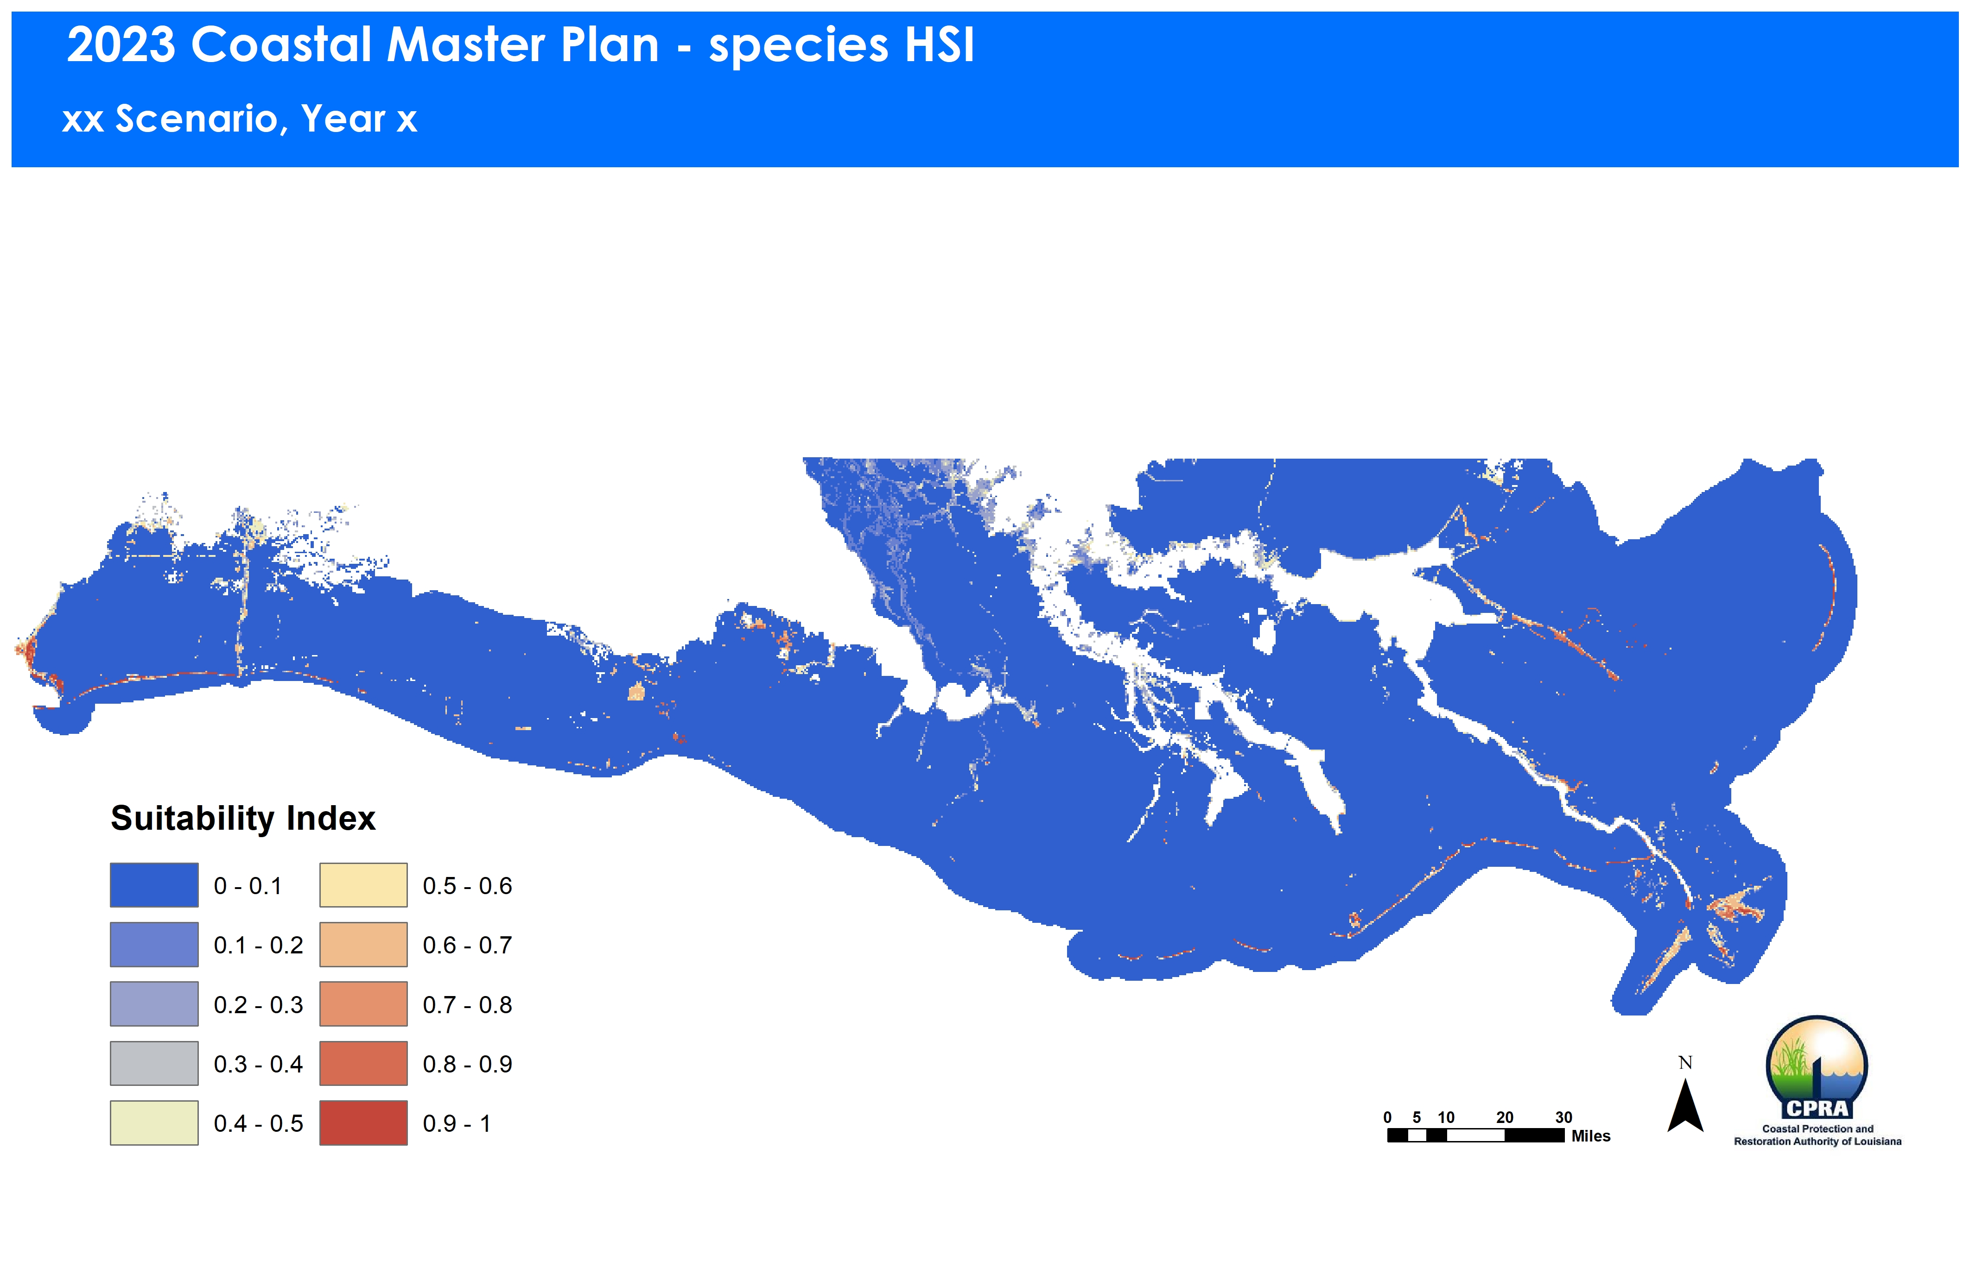 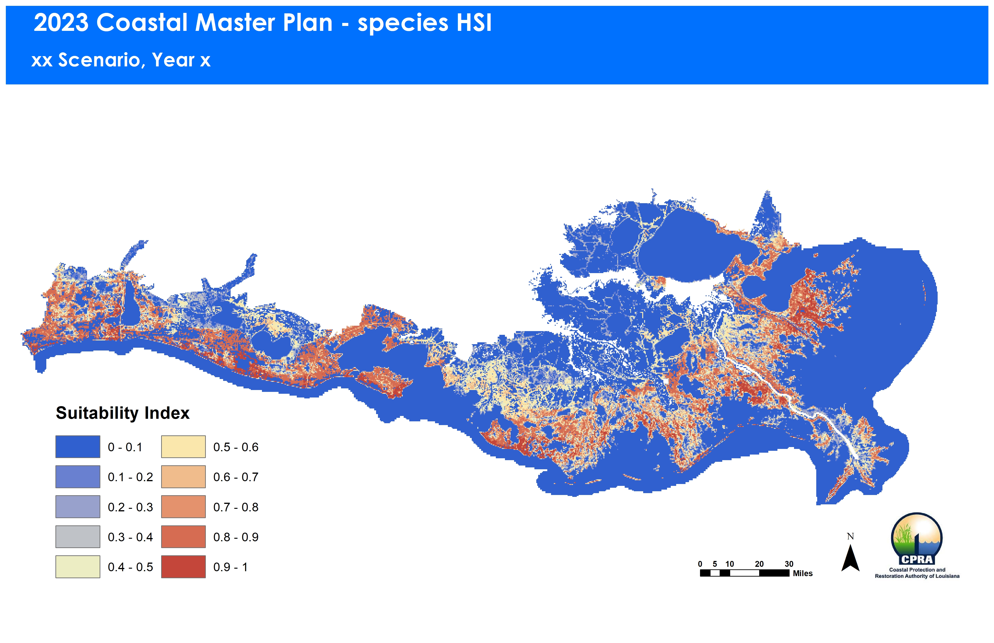

2023 Seaside Sparrow HSI FWOA results 2023 Seaside Sparrow HSI test results

Though it doesn’t explain the issues discussed above, there is an error in the seaside sparrow HSI model code. In Line 1572 of HSI.py the “mean elevation minus stage” calculation is multiplied by 100 to convert the result into centimeters. This, however, isn’t necessary because the subsequent code for the marsh elevation suitability relationship uses elevations expressed in meters (see Lines 1587 through 1590 and the suitability relationship described on page 32 of the technical report). Therefore, the model code in Line 1572 needs to be corrected, and the code in Lines 1587 through 1590 and 1601 should have the “cm” removed for consistency.

* 1. Gadwall

The gadwall HSI calculations need to incorporate the SAV data. I would also like the chance to review the FWOA SAV output when available to determine if adjustments need to be made to the gadwall model SAV variable prior to proceeding.

In addition, there appears to be a problem with the calculations of the proportions of a model cell belonging to various depth classes. The gadwall HSI model only assigns suitability scores to 12 water depth classes that range between 0 and 150 cm. Consequently, there should be many model cells where the sum of all the depth class proportions is relatively low (e.g. <0.5), because these cells are mostly land/marsh or deeper water depths. In contrast, there should also be many cells where the sum is relatively high (≥0.5). In the 2017 gadwall HSI FWOA results, approximately 20% of the model cells had sums greater than 0.5. However, in the 2023 gadwall HSI FWOA results only 0.8% of the model cells have sums greater than 0.5, and a preponderance of cells have sums between 0.4 and 0.5 (i.e., about 23% of cells are within this range). There is an error in the gadwall HSI model in that the proportion calculations appear to be using the 2017 500m grid cells as the unit of area (see Lines 1235 to 1237 of HSI.py). Though this needs to be corrected, the problem in the depth calculations is likely related to the same marsh elevation/water depth averaging issue noted previously.

* 1. mottled duck

The mottled duck HSI FWOA results show reasonable spatial patterns of habitat suitability. However, similar to gadwall above, there appears to be a problem with the calculations of the proportions of a model cell belonging to various depth classes. The issue is more extreme for mottled duck, though, as there only 2 model cells where the sum of all depth classes is above 0.5 and 60% of the cells have sums in the range of 0.4 to 0.5. As for gadwall, there is an error in the mottled duck HSI code, where the calculations appear to be using the 2017 500m grid (see Lines 1118 to 1120 of HSI.py). This needs to be corrected, but again the issue is more likely related to the marsh elevation/water depth averaging issue noted previously.

* 1. Bald Eagle

The bald eagle HSI calculations need to be performed on the larger 6-km grid, rather than the 480-m grid. Otherwise, the general patterns of habitat suitability appear to be reasonable.